Web-Based Music School Manager
Functionality Specification

Author: Aaron Redmond
Student ID: C00002396
Supervisor: Paul Barry

Contents
Project Description 3
Potential Users 4
Navigational Flowcharts 5
Home Page 5
Administrator 6
Student 8
Teacher 9
Functionality 10
Core features 10
System Setup 11
Instruments 11
Subjects 12
Personalisation 13
Account Registration 14
User log In 15
User verification 15
User reminders 16
Data Entry 17
Timetable Creation 18
Navigation 22
Additional features 23
Report Creation 23
News 23
Room Timetable 23

Project Description
The Web-Based Music School Manager aims to integrate the accessibility of the web with the functionality of a school management system.
A school management system allows a school to manage all its data conveniently in one place. Within a school there are many different types of data which need managing. This data is generally comprised of:
- Teacher Data
  - Name, address, subjects taught, etc.
- Student Data
  - Name, address, grade, instrument, etc.
- Subjects
  - The subjects being taught at the school, guitar, violin, etc.
- Classes
  - The division of students. Students may be grouped into classes based upon grade and instrument of choice.
- Lessons
  - These are a combination of subjects, teachers and classes. Example: Music theory, Grade 1 class, with Mr. Teacher.
- Working days/hours
  - The number of days per week and hours per day the school operates.
Also within the management system, there will be a facility for timetable creation. An administrator will be able to create a master timetable, and from this a student and teacher timetables. A timetable can only be created once a certain amount of data has been entered.
Implementing this as a web application allows ease of access for a school’s administrator to access data and timetabling functionalities from a variety of locations rather than having to stick rigidly to one terminal. Running the Music School Manager as a web application also protects against such common threats as hard-drive failure and accidental database deletion.

Potential Users
The potential users of the Music School Manger system are small to medium music schools. These schools are generally run by a handful people who themselves also teach. Usually it’s one of these people that are responsible for the complete administration side of the business.
It is the aim of the Music School Manager to make this person’s job easier by simplifying the tasks associated with the everyday management of a music school. Tasks such as data entry and timetable creation can now be done from any location with one application.

Navigational Flowcharts
In this section we will look at the basic flow of the application. This will help us visualise how a user will navigate the application. The flow of the application can be broken down into the following sections:
- Home Page
- Administrator
- Student
- Teacher
We will look at these in more detail in the following sections.

Home Page
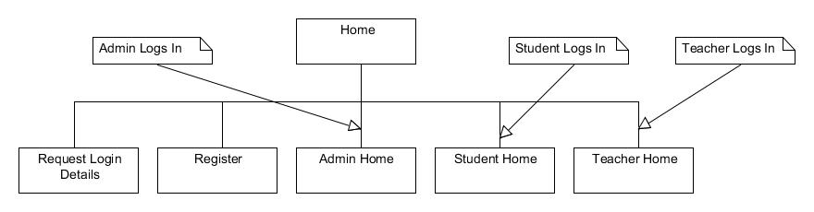
Figure 1: Options available from the home page
From the initial home page a user can:
- Register a new account
- Log in as:
  - Administrator
  - Student
  - Teacher
- Request Login detail
  - If the user has forgotten their username or password, they can request their detail via email from this page.

Administrator
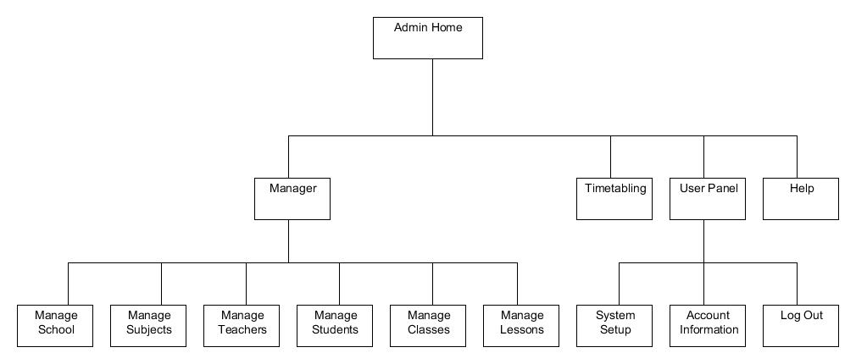
Figure 2: Options available from the administrator home page
If the user logs in as an administrator, they will have the following options available.
- Manager
  - Manage School
    - Displays the school management page, where the administrator can edit information about the school.
  - Manage Subjects
    - Displays the subject’s management page, where the administrator can edit, delete or add subjects.
  - Manage Teachers
    - Displays the teacher management page where the administrator can edit, delete or add teachers.
  - Manage Students
    - Displays the student management page where the administrator can edit, delete or add students.
  - Manage Classes
    - Displays the class management page where the administrator can edit, delete or add classes.
  - Manage Lessons
    - Displays the lesson management page where the administrator can edit, delete or add lessons.
- Timetabling
  - Displays the timetabling section.
- User Panel
  - System Setup
    - Displays the system setup page.
  - Account Information
    - Displays the administrator information, as entered during registration.
  - Log Out
    - If the user selects this option; it will log them out of the system and return them to the initial home page.
- Help
  - Displays system help, possibly page specific.

Student
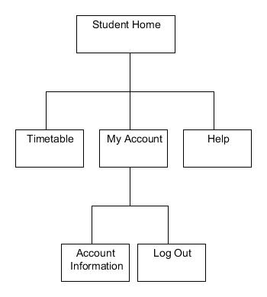
Figure 3: Options available from a student's home page
If a user logs in as a student, they will have the following options available to them.
- Timetable
  - From here, the student can view their individual timetable.
- My Account
  - Account Information
    - Displays the student’s information, as entered by the administrator.
  - Log Out
    - If the user selects this option; it will log them out of the system and return them to the initial home page.
- Help
  - Displays system help, possibly page specific.

Teacher
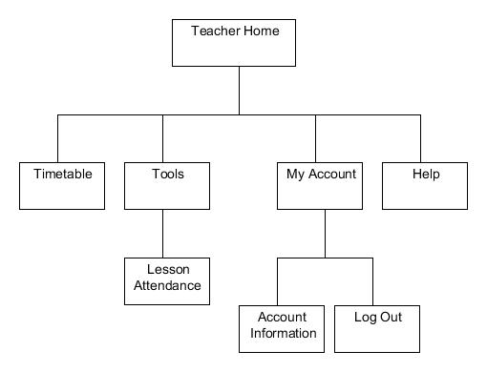
Figure 4: Options available from a teacher’s home page
If a user logs in as a teacher, they will have the following options available to them.
- Timetable
  - From here a teacher can view their individual timetable.
- Tools
  - Lesson Attendance
    - From here a teacher can input the attendance records for their lessons.
- My Account
  - Account Information
    - Displays the teacher’s information, as entered by the administrator.
  - Log Out
    - If the user selects this option; it will log them out of the system and return them to the initial home page.
- Help
  - Displays system help, possibly page specific.

Functionality
The Web-Based Music School Manager will contain mu functionality; which is highly interdependent. We can break the functionality into two sections: core features and additional features.

Core features
This is the functionality that the project must contain in order for it to be successful and useful to any prospective user. The list of core features is as follows:
- System Setup
  - Instruments
  - Subjects
  - Personalisation
- Account registration
- User log in
  - User verification
  - User reminders
- Data entry
- Timetable creation
- Navigation
We will now look at each of these features in the following sections.

System Setup
System setup is a facility which needs to be run on first use of the Music School Manager system. It allows the administrator to setup all the basic options needed for the correct operation of the system. This functionality will also be available to the administrator if they wish to change any features at a future date.
During system setup the administrator will be able to setup the following:
- Instruments
- Subjects
- Personalisation
We will now look at these options in more detail.

Instruments
This option allows the administrator to list all the musical instruments taught at the school. This list of instruments will then be used throughout the application wherever an instrument must be chosen; for example, on the add student page.
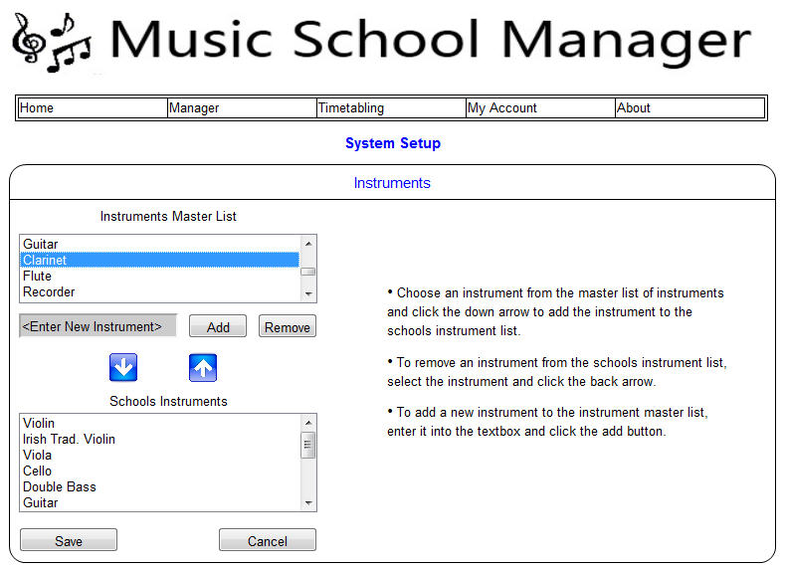
Figure 5: Instruments Setup

Subjects
This option allows the administrator to list all subject taught at the school. This list of subjects will be used in the creation of lessons.
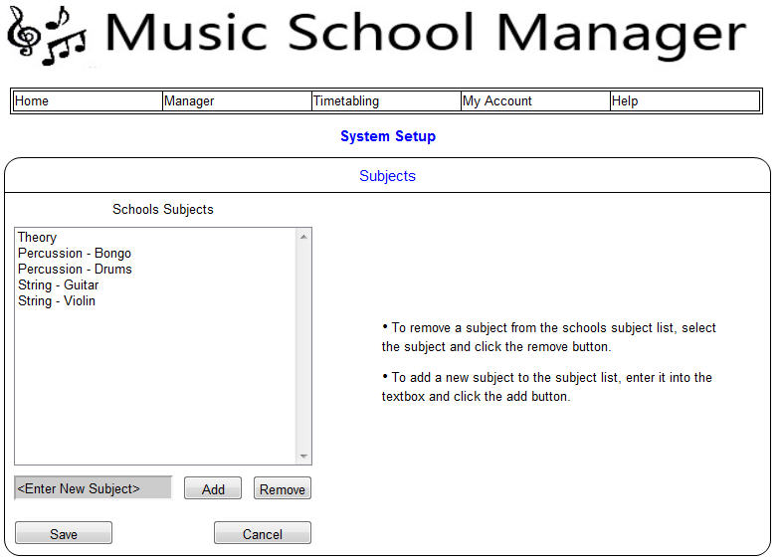
Figure 6: Subjects Setup

Personalisation
An administrator might wish to personalise their schools account with a school logo or school colours. This would give the account a visual association with the school.
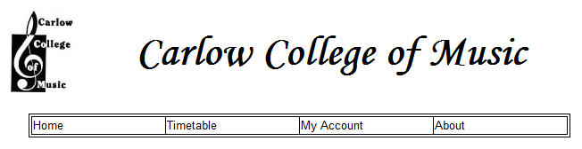
Figure 7: Personalisation Setup

Account Registration
Before a user can log into the Music School Management system and start using the facilities, they must first register an account. To register an account a user must supply the system with some personal information along with some information about the school they belong to.
Students and teachers do not register an account; their accounts will be created by the administrator.
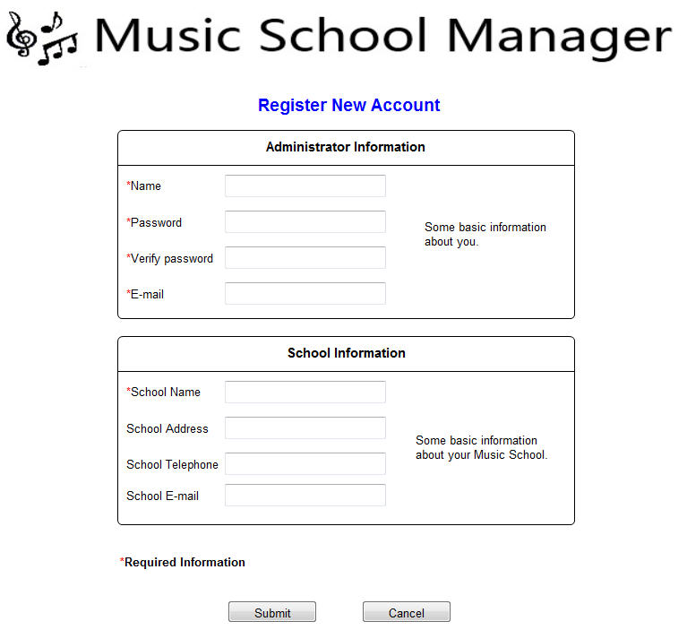
Figure 8: Account Registration

User log In
After completing registration a user must be able to log into the system. A user logs into the system by entering the username and password they supplied during registration.
If the incorrect username is given then the system should display an “Invalid username” message, and point them towards the “Forgot your Username” section. If the incorrect password is given then the system should display an “Invalid password” message, and point them towards the “Forgot your password” section.
Upon successful log in, the user is presented with their personal front page.
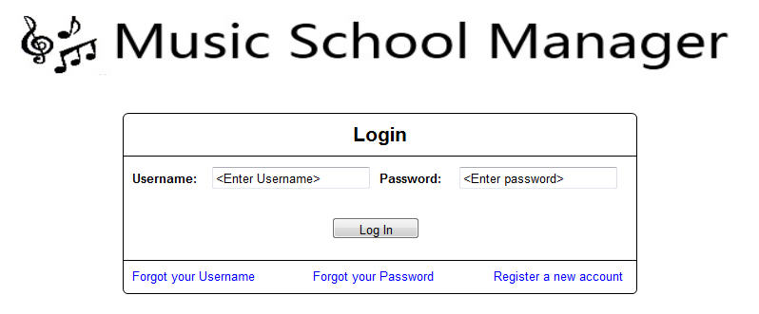
Figure 9: User Log In

User verification
Within this system there are 3 main types of user, which are: administrator, teacher and student. The system should ensure that a user with a student or teacher account cannot log into an administrator account.

User reminders
From time to time a user may forget his or her username or password. The system should provide mechanisms which allow the user to request a forgotten username or password.
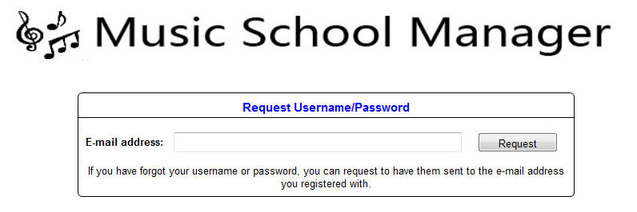
Figure 10: User Reminder

Data Entry
A user must be able to easily enter and edit all data associated with school management. This functionality is dependant upon the user being able to log into the system.
All data entry forms will perform in a similar manner.
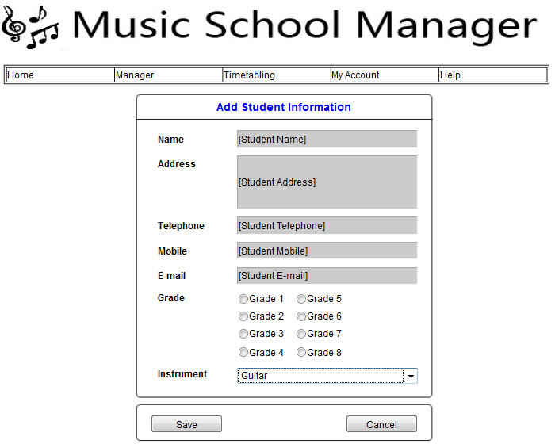
Figure 11: Data Entry form for adding a new student

Timetable Creation
One of the core functionalities of the Music School Manager is the ability to create a timetable. The user should have the ability to generate a timetable with the click of a button. This functionality is dependent upon data entry, as a timetable cannot be created without all the relevant data.
The system will be able to produce three different types of timetable:
- Master timetable
  - This timetable will display the timeslots for all lessons, all students and all teachers.
- Student timetable
  - This will be a subset of the master timetable, showing only the student allocated timeslots.
- Teacher timetable
  - This will also be a subset of the master timetable, showing only the teachers allocated time slots.
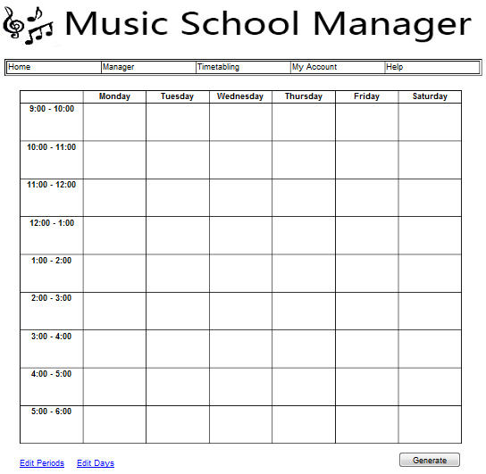
Figure 12: Initial Blank Timetable
This functionality is initiated when the user clicks the ‘Generate’ button. The system executes the timetabling algorithm which uses the data imputed by the user to create the timetable.
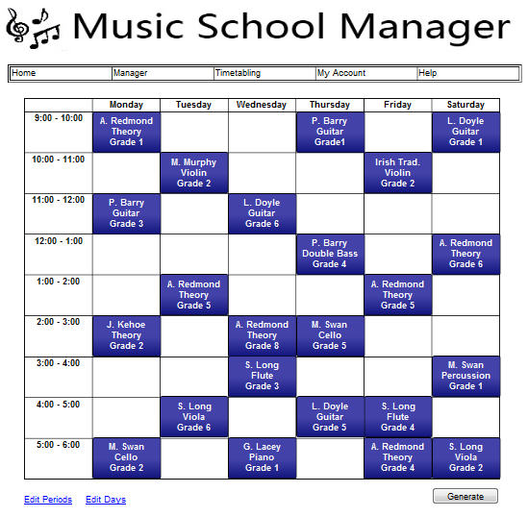
Figure 13: Master Timetable showing all timeslots

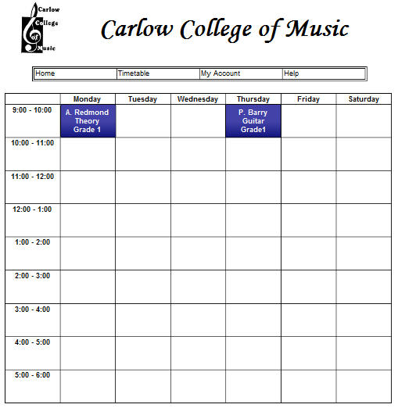
Figure 14: Individual Student Timetable Showing Weekly Theory and Guitar Lessons

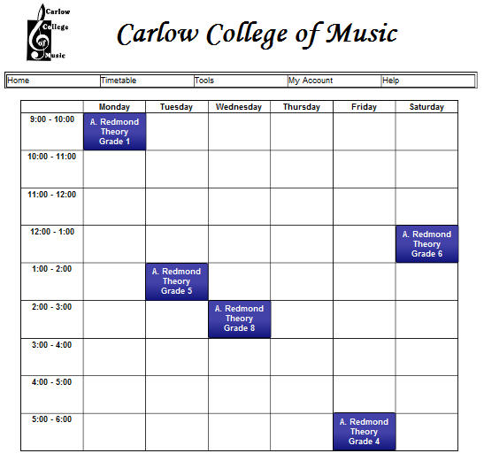
Figure 15: Individual Teacher Timetable Showing all Lessons They Must Teacher in a Week

Navigation
A key feature of any good website or application is the ability to easily navigate the site. Once a user has successfully logged into the site all functionality should be accessible via one or two mouse clicks.
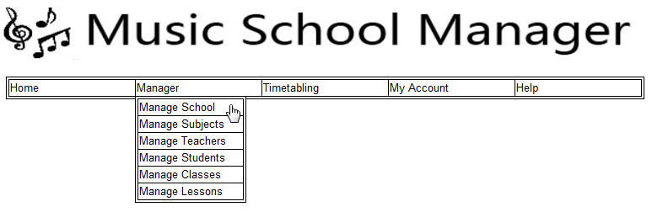
Figure 16: Navigation

Additional features
These are feature which are non-essential to the successful deployment of the application. However they are features which would complement the application and provide extra resources to the school. The list of additional features is as follows:
- Report Creation
- News
- Room timetable

Report Creation
During a school year the administrator may wish to create a report showing a student progress throughout the year.

News
This feature displays the current school news and upcoming events. The news would be updated by the administrator and displayed on the student and teacher home pages.

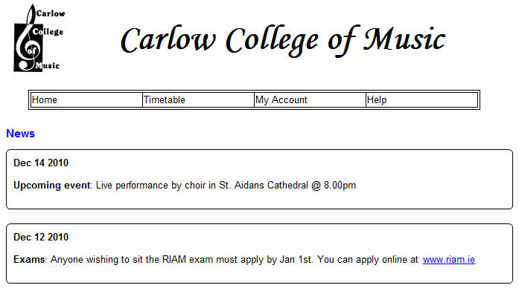
Figure 17: A Student FrontPage Displaying the Latest News

Room Timetable
The added feature of being able to create timetable’s for individual rooms. This functionality would be very useful for easily viewing the availability of a room.

